SVM and the associated concepts

Justin

# Optimum number of supporting vectors

If the data is linearly separable, a smaller number of supporting vectors may be desirable, and vice versa.

Check this [link](https://github.com/rasbt/python-machine-learning-book/blob/master/faq/num-support-vectors.md) for details.

# Kernel selection

The rule of thumb is:  use linear SVMs (or logistic regression) for linear problems, and nonlinear kernels such as the Radial Basis Function kernel for non-linear problems.

In any case, don’t bother too much about the polynomial kernel. In practice, it is less useful for efficiency (computational as well as predictive) performance reasons.

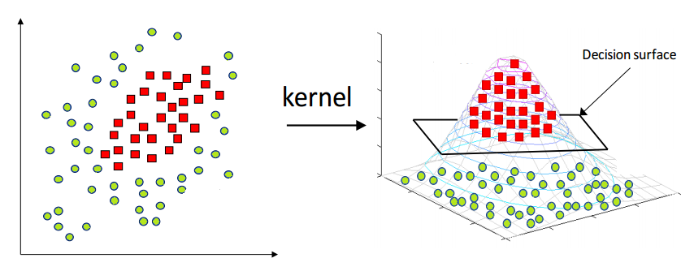

Figure 1. The kernel magic projects the data to higher dimensions and hence makes it linearly separable

# Activation function and loss function